Features

Smart Home Management App Design

**Research: Trends and User Challenges in Smart Home Management**

**Current Trends:**

* **Voice-Controlled Interfaces:** Users are increasingly relying on voice assistants for hands-free operation of their smart home devices.
* **Unified Platforms:** A trend is emerging towards centralized systems that manage all smart devices through a single interface.
* **Energy Efficiency Focus:** There is a heightened emphasis on monitoring and reducing energy consumption.
* **Security and Privacy:** Concerns about data security and user privacy are becoming more prominent.
* **Device Fragmentation:** Managing a wide variety of devices and applications remains complicated.
* **Customization Limits:** Existing customization options often do not fully meet user needs.
* **Routine Automation:** Users are looking for applications that can automate daily tasks and streamline routine management.
* **Advanced Features for Experienced Users:** Say IoT users seek more intuitive interfaces and advanced functionalities.

**Pain Points:**

* **User-Friendly UI:** There is a strong need for an intuitive interface that makes navigation and control seamless for users.
* **Energy Management:** Current tools for tracking and managing energy consumption are insufficient.
* **Real-Time Cost Tracking:** Users desire real-time comparisons between estimated and actual energy costs.
* **Routine Configuration:** There is a need for better tools to schedule and automate device routines.

**Design Explanation**

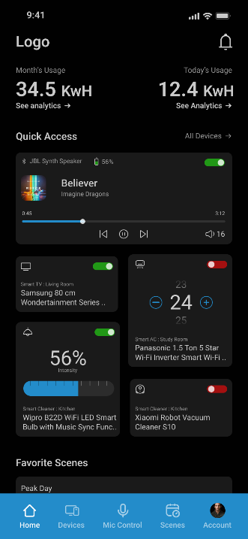**Home Screen Overview**

**1. Top Sections: Usage Tracking**

* **Top-Right Section:** Displays today's electricity usage, allowing users to monitor daily consumption.
* **Top-Left Section:** Shows the entire month's electricity usage, helping users track their overall consumption trends.
* **Purpose:** These sections, combined with analytical charts, encourage users to be mindful of their energy consumption and make improvements.

**2. Quick Access Section**

* **Frequent Devices:** Displays the 4 most frequently used devices for easy access.
* **All Devices:** Clicking the "All Devices" CTA reveals a full list of 10-16 devices.
* **Benefit:** This reduces screen-switching, allowing users to find and control their devices more quickly and efficiently.

**3. Favourite Scenes**

* **Custom Scenes:** Displays user-created scenes in a scrollable section for easy access to preferred settings.
* **Empty State:** If no scenes are created, or if the user does not wish to use this feature, a placeholder rectangle with the text "Make your first scene" and a "+" CTA is shown to encourage scene creation.

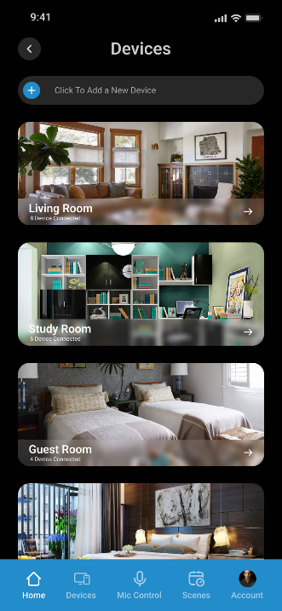**Device Screen Overview**

**1. Add New Device**

* **CTA at the Top:** The screen features an "Add a New Device" CTA at the top.
* **Navigation:** Clicking this CTA takes the user to a new screen for adding devices.

**2. Connected Devices by Room**

* **Scroll Format:** All connected devices are displayed in a scrollable format, organized by room.
* **Benefit:** This layout makes it easier for users to find and manage devices based on their room location.

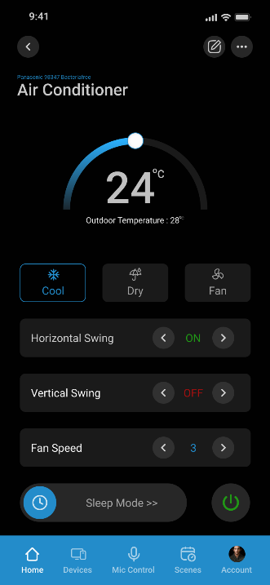

**AC Screen Overview**

**1. Access Points**

* **From Device Screen:** The AC screen can be accessed by clicking on the AC icon in the device screen.
* **From Quick Access:** Alternatively, it can be accessed from the quick access section on the home screen.

**2. Comprehensive Remote Features**

* **User-Friendly Layout:** All remote control features for the AC are presented in an easy-to-understand format, ensuring smooth user interaction.

**Security Feature Overview**

**1. Door Connection**

* The security feature allows the user to connect all the doors in their home to the system.

**2. Alarm Activation**

* When the user activates the alarm feature (e.g., during a family trip or when no one is at home), any door that opens will trigger an alert.

**3. Phone Alerts**

* **Vibration Alert:** If a door is opened, the phone will vibrate for 10 seconds.
* **Ringtone Alert:** If the phone is not in vibrate mode, it will play a ringtone to notify the user.

**4. Missed Alerts**

* If the user misses the alert, a notification will appear in the notification panel for later reference.

**5. Feature Access**

* This security feature can be accessed from the device screen for easy management.

**6. Auto-Lock Functionality**

* If a door remains open for more than 15 seconds and no family member is nearby, the door will automatically lock (if equipped with an auto-lock feature).

**Prototype Link**

<https://www.figma.com/proto/0ThDEFGIE1Na2veQ5V9IaG/smart-home?page-id=0%3A1&node-id=43-2&viewport=398%2C337%2C0.71&t=eKmJVSbBxJM4CZcI-1&scaling=scale-down&content-scaling=fixed>

**Mockups**

